6373793

WEEK-2 COGNIZANT DIGITAL NURTURE 4.0

PL/SQL programming

Exercise 1: Control Structures

Creating the data:

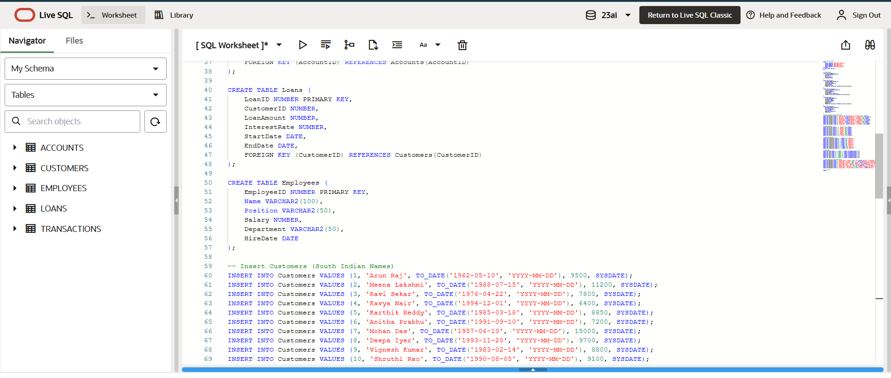

Output:

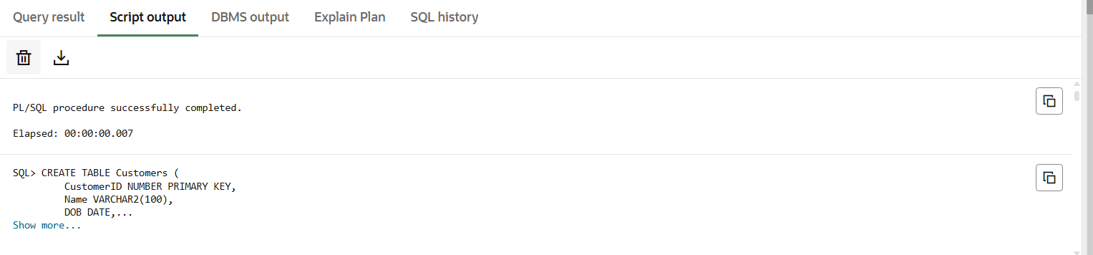

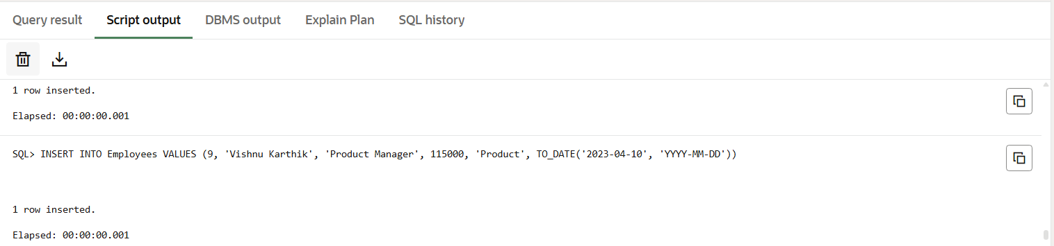

**Scenario 1:** The bank wants to apply a discount to loan interest rates for customers above 60 years old.

Code:

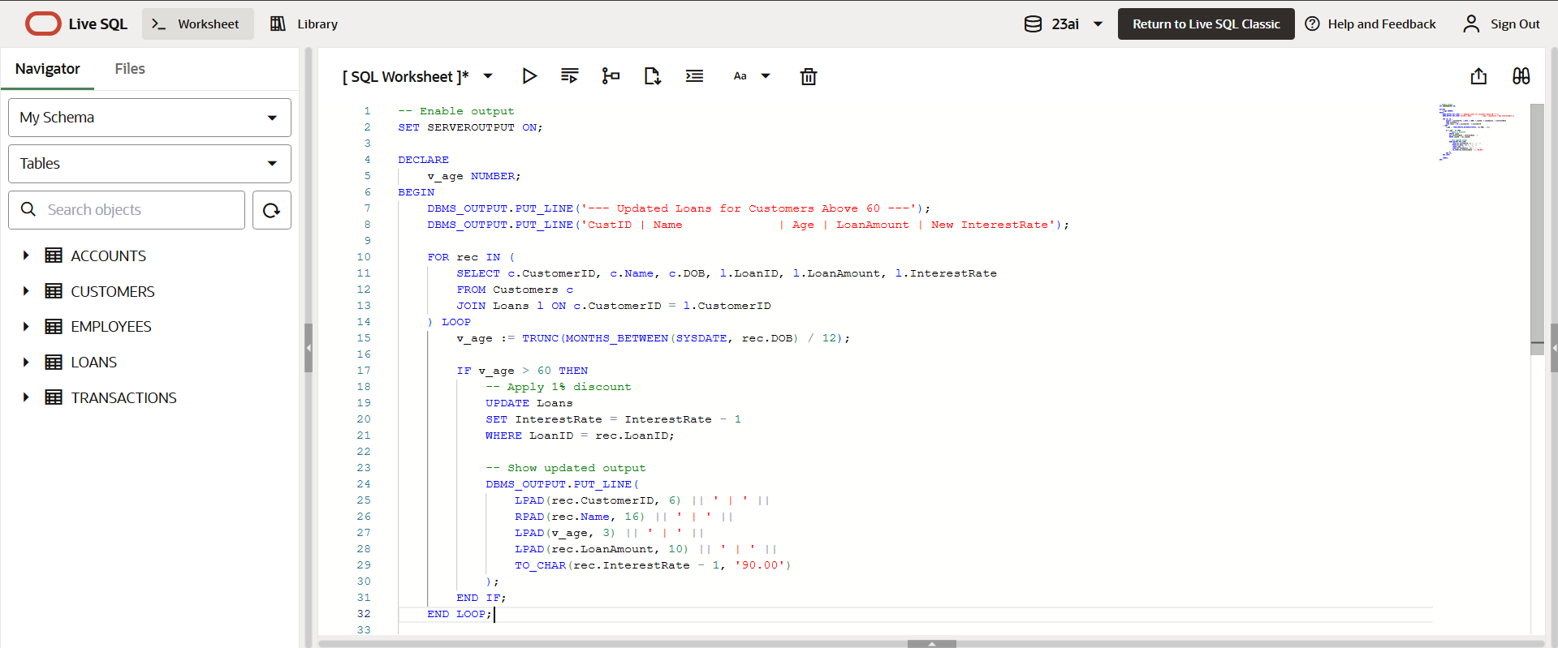

Output:

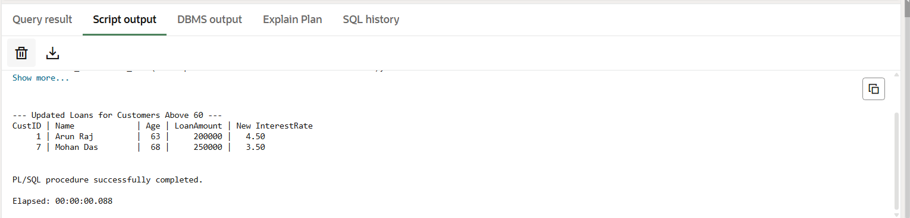

**Scenario 2:** A customer can be promoted to VIP status based on their balance.

Code:

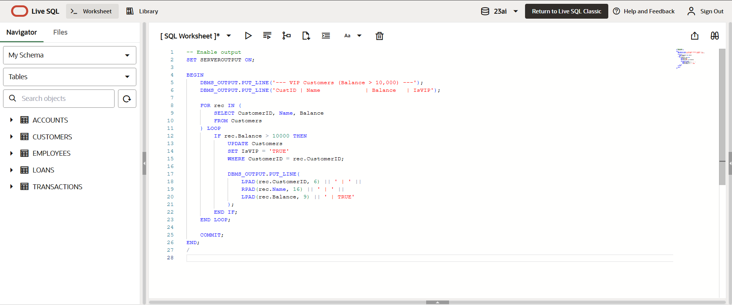

Output:

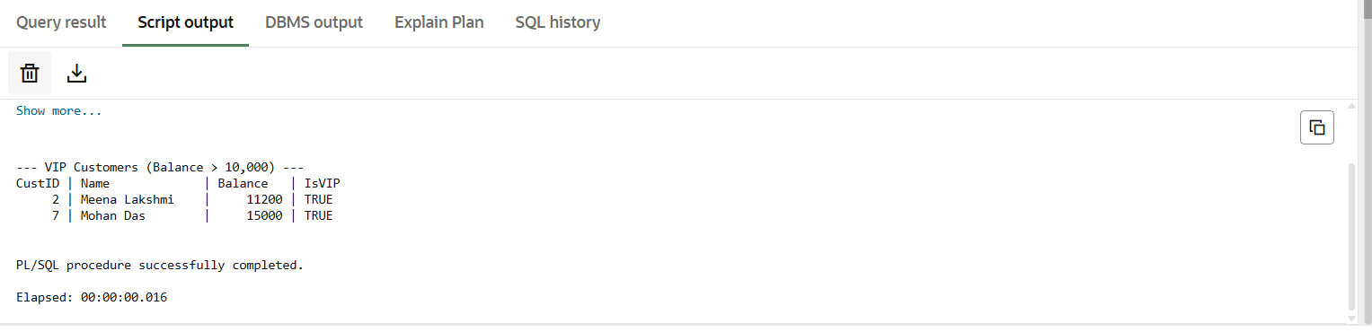

**Scenario 3:** The bank wants to send reminders to customers whose loans are due within the next 30 days.

Code:

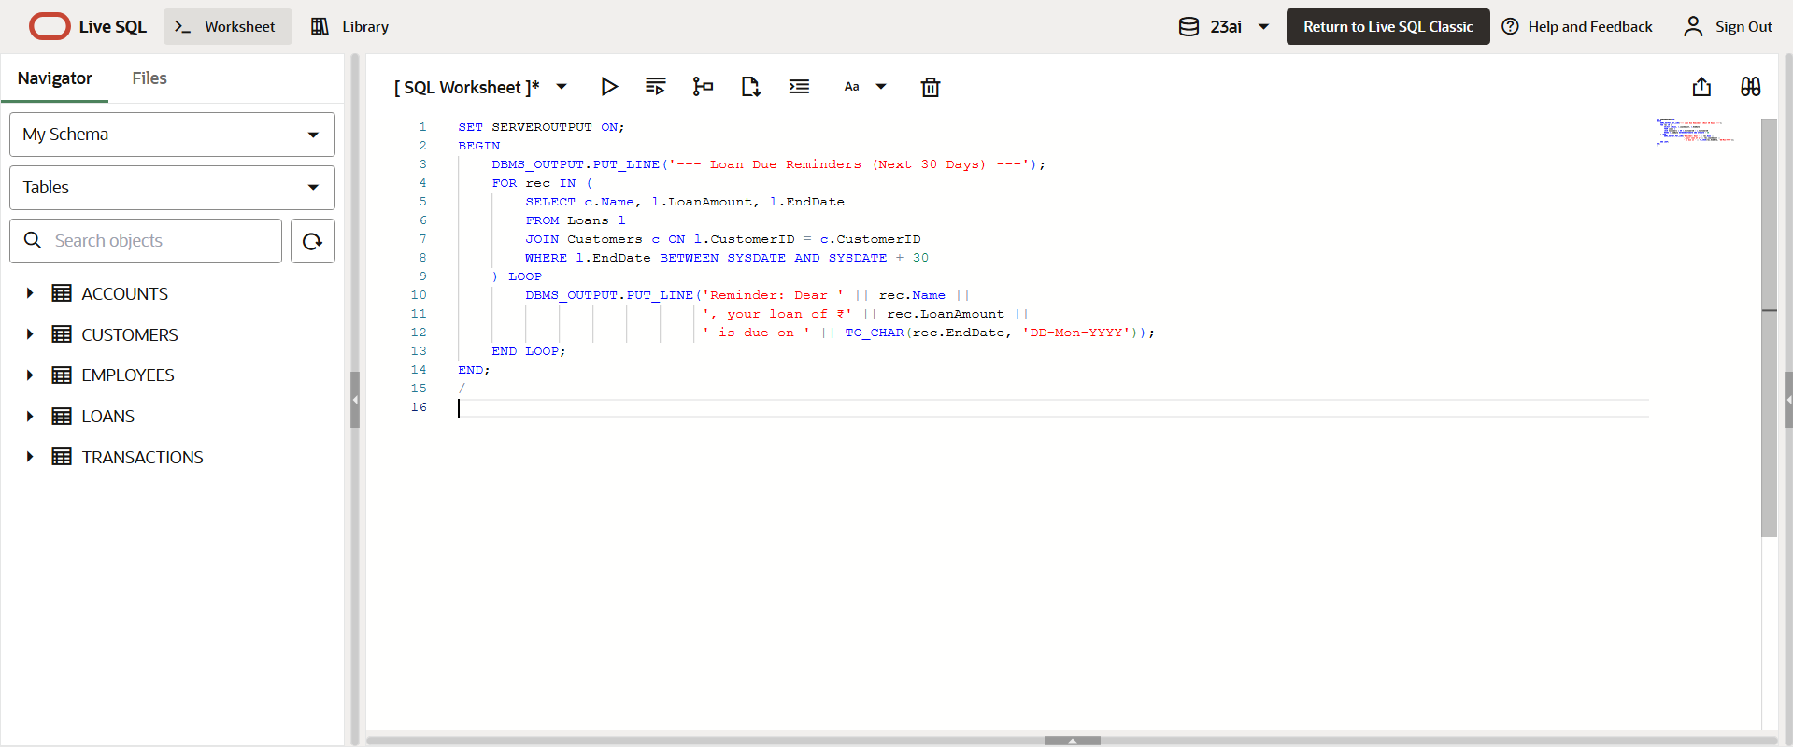

Output:

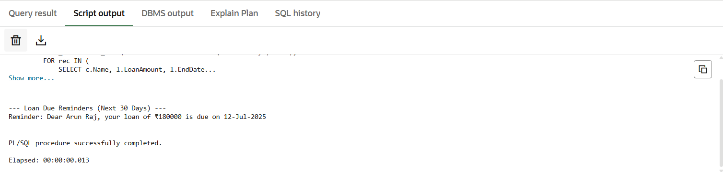

Exercise 3: Stored Procedures

**Scenario 1:** The bank needs to process monthly interest for all savings accounts.

Code:

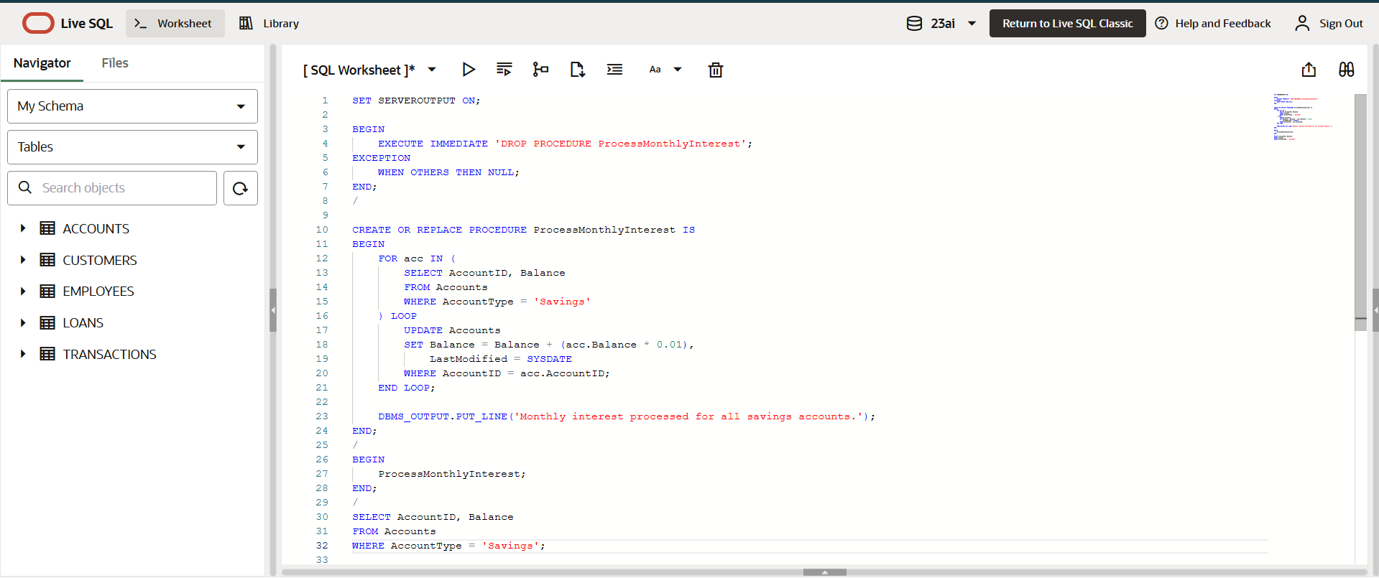

Output:

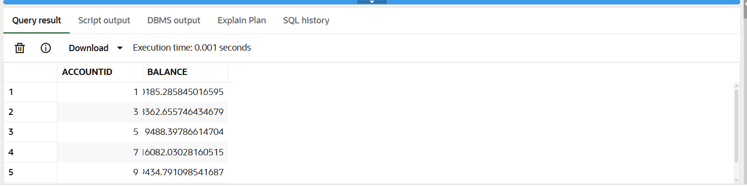

**Scenario 2:** The bank wants to implement a bonus scheme for employees based on their performance.

Code:

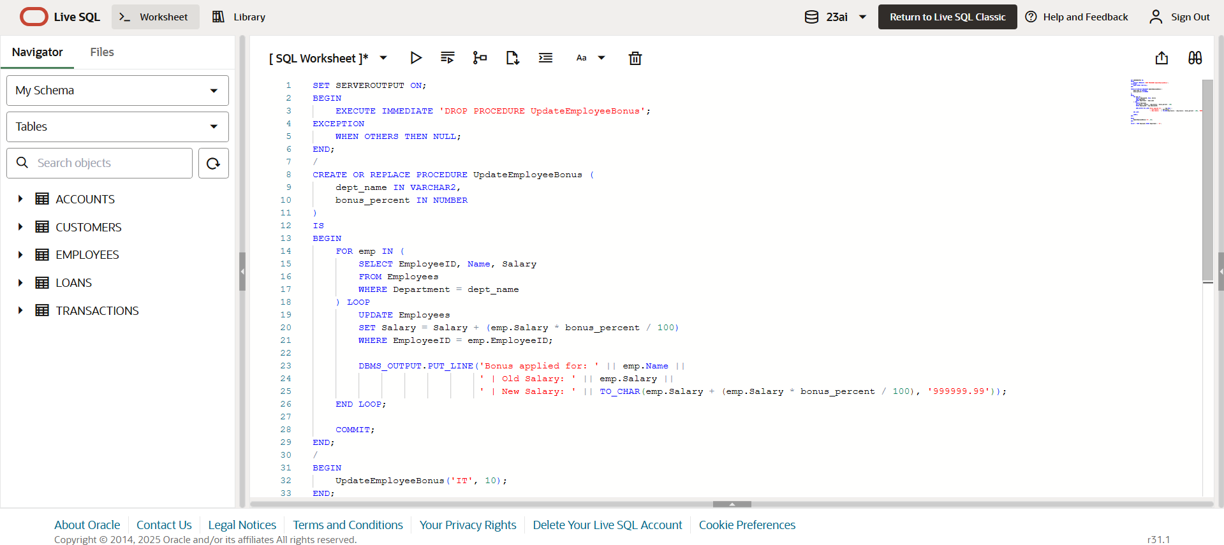

Output:

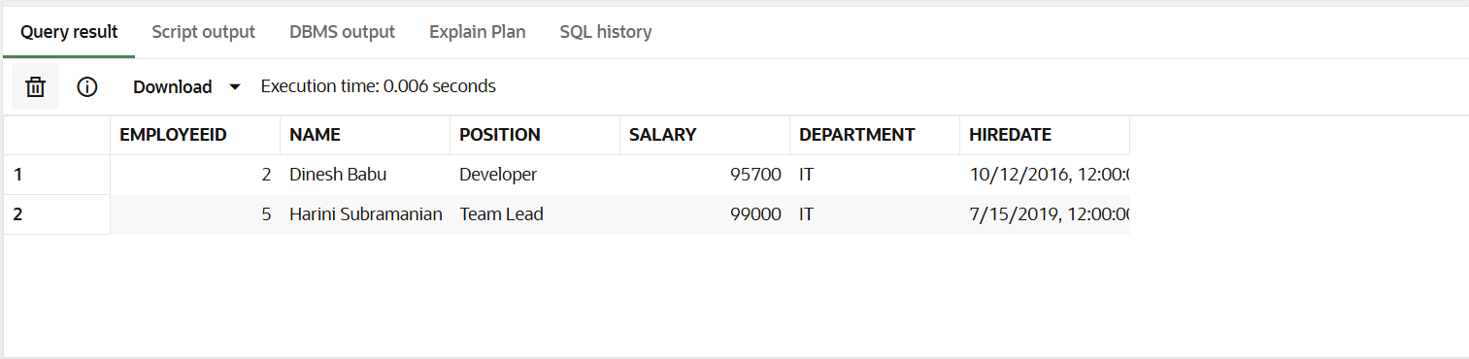

**Scenario 3:** Customers should be able to transfer funds between their accounts

Code:

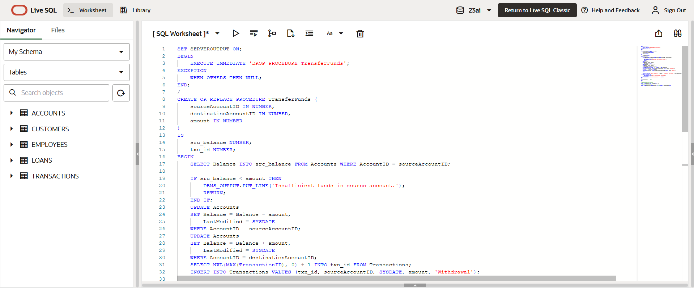

Output:

